Cross Cultural Exchange-Cuba Itinerary

Day 1
Welcome to Havana
Transport to your accommodation for check-in. Once you are settled, your tour guide will take you out to eat. In the evening, you will attend a special event put together by Cuban artists to welcome you to Cuba. You will have a chance to mingle, ask questions and make friends. Appetizers and drinks will be served.
Day 2
Tour of Havana
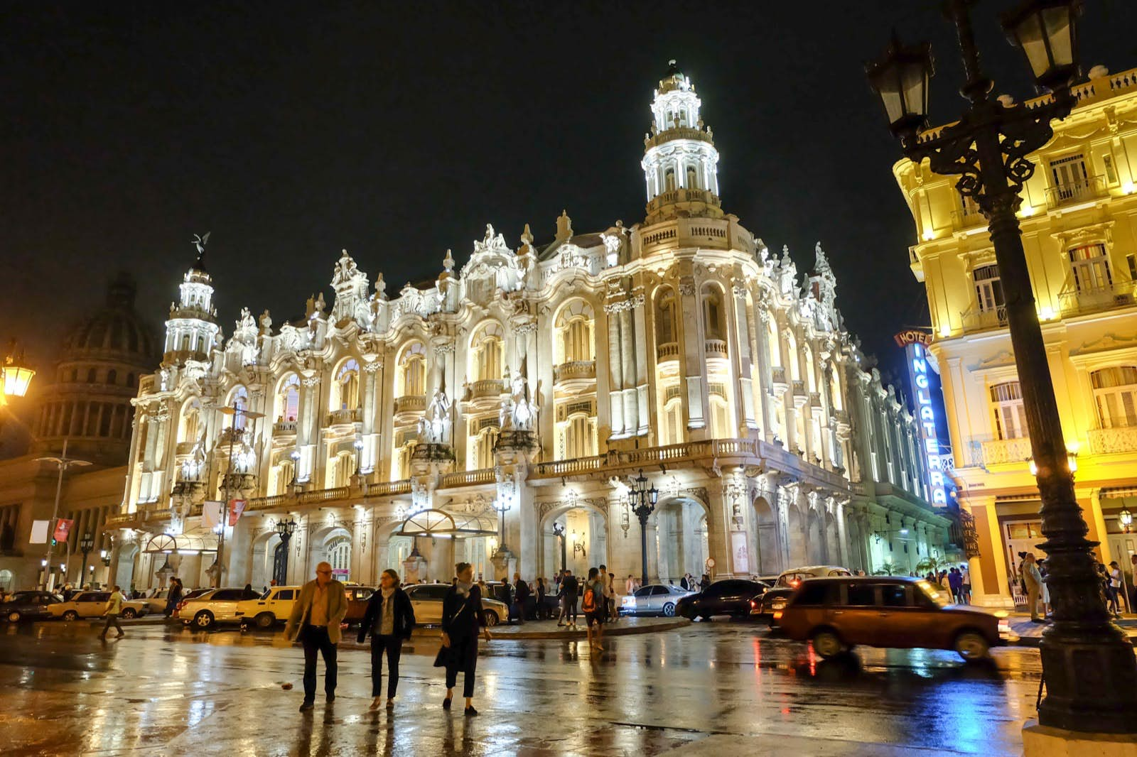

We will head to the historical center of Havana: Plaza the Armas, Cathedral Square, Plaza de San Francisco de Assis. Walk in Obispo Street until Hotel Ambos Mundos, El Floridita, the most famous bar/restaurants and one of Hemingway’s in Havana, Capitolio, Grand Theater, Central Park.

8:00 PM Fortaleza de San Carlos de la Cabaña
Every night for 350 years, a cannon has been fired from the Fortaleza. Originally to signal closure of the City Gates and harbor, it lives on today as a source of local entertainment and pride. This event attracts many tourists every night 365 days a year.

9:30 PM Visit to Hotel Nacional to watch the Malecon Boulevard, take some great photos and discover all the famous American dignitaries who have stayed at the hotel.

Day 3

Museum of Fine Arts
Havana Rhum Museum
Casa de La Música 11 PM for salsa lessons and dancing

Day 4

Las Terrazas-An integrated eco-village 1 Hour from Havana

Las Terrazas is a settlement which is located within the Sierra del Rosario Biosphere Reserve in the Artemisia Province. It is a UNESCO Biosphere reserve. It is rich in flora and fauna, historic sites, lakes, rivers and waterfalls. It is also home to about 1000 inhabitants of peasants, workers, artists, musicians, craftsmen who offer its visitors a magnificent experience in sustainable development in Cuba. We will visit a coffee plantation where enslaved people worked the land for their masters.
Enjoy hiking, biking, horseback riding, swimming, zip lining and more while learning how the community is working to protect the biosphere. While there, enjoy one the best meal you will find in Cuba.
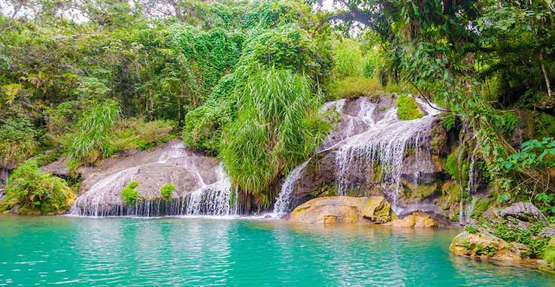

Day 5
Playa Santa Maria-Enjoy a great day at the beach listening to some live musical performances and eating fresh grilled fish or Lobster.

Tropicana 10 PM
This "paradise under the stars" is located within a kind of tropical forest with gigantic trees: royal palms, mamoncillos, mango trees, cedars and other representatives of the local flora and has been in operation for more than 50 years. In 1992, the North American Restaurant Industry Academy honored Tropicana with the Best of the Five Diamond Stars, for being the best cabaret in the Americas. Entertainers like Nat King Cole, Josephine Baker, Libertad Lamarque, Cheo Feliciano, Rita Montaner, Elena Burke and Bola de Nieve are some of the celebrities who performed in this cabaret under the stars of the Havana sky.

Put on your best outfit for this fanciest cultural event in Cuba. After the show, you might be invited to take some dance lessons on stage.

Day 6

Can never get enough of this beautiful city! We will be heading to the Christopher Columbus Cemetery, the botanical garden, and various museums in Havana as time allows. We will then take a ferry from Old Havana to the Port of Regla to visit a beautiful, historic maritime church built as a sanctuary to house the black Virgin of Regla.

Fabrica De Arte Cubano 9 PM
Declared by Time Magazine as ‘One of the World’s 100 Greatest Places’ in 2019, Fábrica de Arte Cubano (Cuban Art Factory), or simply ‘Fábrica’ as locals refer to it, blends the cutting edge of Cuban contemporary art, design, theatre, fashion, and music.

This "paradise under the stars" is located within a kind of tropical forest with gigantic trees: royal palms, mamoncillos, mango trees, cedars and other representatives of the local flora and has been in operation for more than 50 years. In 1992, the North American Restaurant Industry Academy honored Tropicana with the Best of the Five Diamond Stars, for being the best cabaret in the Americas. Entertainers like Nat King Cole, Josephine Baker, Libertad Lamarque, Cheo Feliciano, Rita Montaner, Elena Burke and Bola de Nieve are some of the celebrities who performed in this cabaret under the stars of the Havana sky.

Put on your best outfit for this fanciest event in Cuba.

Day 7 Saturday August 24
Hasta Pronto Cuba!
Eat breakfast then and check out.
You will be driven to Jose Marti Havana International Airport 3 hours prior to departure flight. This cultural exchange is designed to be an experience of a lifetime.
Included in this package:
- Round trip airfare
- Round trip transportation from Jose Marti Airport to accommodation
- Accommodation for 7 nights
- Welcoming party with live performance of Cuban artists
- Three meals daily (breakfast and lunch and dinner)
- One alcoholic beverage with lunch and dinner
- Paid transportation to all the sites to be visited
- Paid tour guide fees
- Entrance fees to all sites to be visited

